Retinal Damage Detection using OCT images

Subhadip Nandi, Piyush Mudgal

*School of Computer Science and Engineering, Vellore Institute of Technology*

snandi640@gmail.com

pmudgal22@gmail.com

***Abstract*— Optical Coherence Tomography (OCT) has become a potent diagnostic tool for retinal disorders through high-resolution imaging. This review delves into recent developments in the identification of retinal damage from OCT images. Convolutional Neural Networks (CNNs) are one of the deep learning models that have been suggested to increase diagnosis accuracy. Scaling and segmentation are important image preprocessing techniques that help these models function more efficiently. Texture-based methods have also been investigated for the detection of anomalies in retinal OCT images, offering a thorough overview of alternative methodologies.**

**In addition, the use of deep learning-based identification systems facilitates accurate classification of retinal illnesses, highlighting the promising future of OCT in clinical settings. This paper makes a contribution to the field by presenting a three-step system for diabetic retinopathy detection, demonstrating the potential of OCT in diverse retinal conditions.**

***Keywords***— **Diabetic Retinopathy, Optical Coherence Tomography (OCT), 3D-OCT Retina Layer Segmentation, Deep Learning, Disease Detection Algorithm, Image Preprocessing, IoT-based OCT, Retinal Diseases Classification, Coherent Convolution Neural Network, Automated Diagnosis**

1. Introduction

Because OCT can produce high-resolution, cross-sectional images of the retina, which helps clinicians to detect subtle structural changes associated with a variety of retinal diseases, it has become a crucial imaging modality for the early diagnosis and monitoring of retinal disorders. This paper explores the developments and methodologies used in the field of retinal damage detection through OCT images.

In order to improve the accuracy of disease detection, researchers have been actively investigating the integration of deep learning algorithms in the detection of retinal damage using OCT images. Among the notable contributions are the development of Convolutional Neural Networks (CNNs) for the precise detection and classification of retinal disorders, as well as novel approaches like FN-OCT algorithms that highlight the importance of image preprocessing, including scaling techniques.

This work examines the body of research on the classification of retinal diseases from OCT images, looking at both conventional and cutting-edge texture-based techniques. Moreover, the incorporation of IoT-based OCT systems gives retinal diagnostics an additional level of accessibility and connectivity.

We explore the methods, difficulties, and potential applications of using OCT imaging to identify retinal deterioration in the upcoming sections.

1. LITERATURE REVIEW

OCT technology has been at the forefront in the modern ophthalmic world, offering exquisite images of the retinal layers by the least invasive means. The progress of OCT technology over time has made possible retinal imaging and detection of ocular pathology. The focus of this literature survey is the trajectory that led from the initial versions to today’s most advanced approaches used for detecting retinal deterioration using OCT images. This guide takes you though the development of OCT technology. The article explains the early innovations which laid down the cornerstone for the development of OCT into one of the most important tools for examining the various pathologies of the retina. Moreover, the survey is very specific about how old technologies advanced over the years, highlighting their merits, weaknesses, and key breakthroughs, making the old methods used in recent OCT setups.

This section maps out a historical trajectory alongside in detail reviewing the current practice OCT technologies. The article explores the intricate aspects of modern innovations and their relevance in improving accuracy, image resolution, and diagnosis in glaucoma detection and characterization. This review work attempts to describe how OCT technology has developed as a tool for retinal imaging and detecting pathologies via comparing old and new technologies. This study traces through an intricate scrutiny of the history of OCT along with its recent innovations to map out the pathway of development as well as to outline the fundamental breakthroughs and hurdles encountered in retinal imaging. Further, the paper tries to highlight the possible pathways in which the next-generation

technology can be explored in order to

further improve how OCT is used to detect

and manage the condition.

On improving the use of OCT imaging for

detecting glaucomatous damage

In 2014, The British Journal of

Ophthalmology suggested ways to improve

the diagnosis of glaucoma using OCT. In

one technique the structural differences were

analyzed in the optic nerve head and retinal

layers using the OCT images. Nonetheless,

the paper cites to a different methodology

without describing exactly how it is done.

These were two approaches geared towards

improving early glaucoma detection that is

vital for prompt intervention. This paper

emphasizes the target and measuring

information of OCT that eliminates the

medical judgment of the diagnosis.

Importantly, OCT is a non-invasive method

and quite well tolerated by patients.

However, technical challenges that may

affect image quality and reproducibility,

heavy dependence on operator skill for

effectiveness and the high costs of OCT

equipment and examinations are some

barriers which might restrict it as a general

clinical service tool in particular settings or

within certain age demographics.

**An Attempt to Detect Glaucomatous**

**Damage to the Inner Retina with the**

**Multifocal ERG**

The main method for this research on

detection of glaucoma-related inner retinal

damage is mERG which uses a 103 element

stimulus array for examining retinal

functioning in specific points. mERG holds

the potential for early detection of damage

to the inner retina, an important

consideration for successful treatment. It

delivers an objective and quantitative

assessment of retinal function, leading to a

drop in diagnostic bias. The mERG is highly

sensitive for detection of damage prior to

visual field abnormality, which improves

diagnostics. Nevertheless, the research

recognizes limitations associated with the

mERG technique which is not revealed in

the details. Further, data gathered through

mERG detection suggest that mERG

detected damage might occur earlier before

the appearance of VF deficits in a particular

Situation.

**Utility of optical coherence tomography**

**angiography in detecting vascular retinal**

**damage caused by arterial hypertension**

The study examines the usefulness of OCTA

in identifying vascular retinopathy

associated with essential hypertension.

OCTA is a non-invasive way of seeing

retinal blood flow at very fine precision and

in detail using a technology that detects

small movements among red blood cells to

see in motion contrast. It is less invasive

thus more convenient to the patient and

decreases the chances of infection and

complications. Moreover, due to its high

resolution, OCTA can detect minute

alterations induced by arteriol hypertensive

disease within the retinal vessels, giving

time-effective as well as volumetric data for

complete examination. It targets the

superficial retina though, but it may miss

deeper layer lesions as a limitation.

Additionally, the high cost of the OCTA

equipment in some health setups as well as

depending upon operator skill for obtaining

the right images and interpreting them make

it a challenge to widely apply it towards

detection of vascular retinal damage caused

by arterial hypertension.

**Experimental detection of retinal**

**ganglion cell damage in vivo**

The experimental detection of RGC damage

in a transgenic mouse model that contains

specific genetic tagging for RGCs will be

explored within this research. Using optical

coherence tomography (OCT) for high

resolution imaging of retinal-layers,

especially inner nuclear layer RGC layer

was non invasive, reproducible

measurement of retinal-ganglion-cell

damage (RCD). It is possible to study the

RGC in the controlled environment provided

by the transgenic mice model and observe

even mild alterations in the cells through the

use of confocal microscopy. However,

translating directly the results from these

models into humans is limited. It should be

cautious about its validity for specific RGC

damage in a clinical case. In addition, the

needed high-level apparatus and knowledge

associated with more complicated imaging

strategies as OCT create an obstacle for its

universality. Although improvements in

optical procedures may improve RCG

determination; it is important that the

clinical relevance of the results to human

retinal diseases be established first.

**Transfer learning-based detection of**

**retina damage from optical coherence**

**tomography images**

Transfer learning is a deep learning method

used in this study to detect retinal damages

of digital OCT imaging. Transfer learning

uses pre-trained neural networks on massive

datasets to shorten training time without

requiring large volumes of data or computer

power. This generates a high level of

accuracy in identifying retinal problems

through extraction of pertinent

characteristics derived from the OCT

images, suggesting possible use of it among

diverse retinal diseases thereby proving the

method useful. Nonetheless, the success of

transfer learning is driven by the nature of

the prior dataset since inadequate and

restricted data may impair performance.

Also, there exist complications associated

with extending transfer learning models to

different OCT datasets and diverse retinal

pathologies quite distinct from the

preparation data. However, deep learning

models are also complicated and need a lot

of computer resources to be applied which

makes it more difficult to use in the real life

World.

**Can Macula and Optic Nerve Head**

**Parameters Detect Glaucoma Progression**

**in Eyes with Advanced Circumpapillary**

**Retinal Nerve Fiber Layer Damage?**

The aim of this study is to look at whether

OCT can be a useful tool in identifying

glaucomatous changes ONH and macula

parameters in patients with advanced

glaucoma. Using OCT, a non-invasive

imaging method for detailed retinal

structural data, this study determines how

different ONH and focal macula measures

can be used to indicate worsening disease.

OCT enables patient friendly following up

on tumor development with objective and

quantifiable measurements for accurate

estimation. These aim at revealing clues

regarding how the disease is progressing,

despite circumpapillary retinal nerve fiber

layer breakdown. Nevertheless, some

limitations are identified in this study which

focuses only on advanced glaucoma that

might not be directly applicable to earlier

stages of the disease. Further more, since

some of these parameters may require expert

interpretation, certain parameters will need

validation as being relevant clinically.

However, generalization may be limited

because different presentations of glaucoma

could hinder broader utilization of the

Findings.

**Retinal Damage Thresholds from**

**Single-pulse Laser Exposures in the**

**Visible Spectrum**

Experimental investigation is used in this

study to determine the retinal damage

thresholds that arise from a single pulse

laser exposure in visible spectrum. The

studies are directed at evaluating the laser

effect on the retina, as well as pinpointing

the damage thresholds. It is first noted that

this work contributes greatly in enhancing

safety evaluations for laser exposure

occurring within the visible spectrum

through establishing specific damage

thresholds. The study gives important

information about how quantitative data

analysis could establish safety standards and

guide lines of retinal laser exposure thus

enhancing the understanding of the dangers

associated with such exposure. Nevertheless,

constraints such as a narrow scope towards

the visible spectrum only possibly make it

difficult to apply directly on other

wavelengths. Additionally, this being an

experiment may lead to some disparities

with respect to the setup condition and data

coverage in certain dimensions of laser

damage threshold estimates.

**Retinal Microvascular Abnormalities and**

**their Relationship with Hypertension,**

**Cardiovascular Disease, and Mortality**

This study conducts an extensive literature

review to investigate the correlations

between retinal microvascular abnormalities

and conditions such as hypertension and

cardiovascular disease. By synthesizing

clinical data and evidence from prior

studies, it aims to delineate the relationships

between retinal health and various health

outcomes. Offering a comprehensive

understanding of this connection, the

research is poised to provide valuable

clinical insights into the associations

between retinal microvascular abnormalities

and cardiovascular conditions. However, its

dependence on existing studies could inherit

limitations present in prior research,

potentially impacting the reliability of

conclusions. Additionally, being a literature

review, it might lack access to primary data

or clinical trials, limiting the ability to

conduct original experiments. Moreover,

given its publication date in 2001, newer

research developments in the field may not

be incorporated, potentially limiting the

coverage of recent advancements.

**Electroretinography combined with**

**spectral domain optical coherence**

**tomography to detect retinal damage in**

**shaken baby syndrome**

In shaken baby syndrome, ERG and SD

OCT work together to determine retinal

damage. Through ERG, it is possible to

measure electric activities in retional cells as

result for light, which gives more insight on

retinal functionability. On the other side, SD

OCT offers high resolution image for easy

identification of little retinal injuries as well

subtle structures abnormality. Integration of

ERG’S functional scoring and SD OCT

specific imaging increases clinical

significance of identifying retinal insult in

SBS. In contrast, the processes that use ERG

and SD OCT may prove to be costly,

involving expensive machinery and specific

skills. Moreover, performing such activities

with babies or small children could be

challenging given that they may not

cooperate adequately. In a study, ethical

consideration in pediatric patient is one of

the areas that requires maximum caution.

**American Chinese Glaucoma Imaging**

**Study: A Comparison of the Optic Disc**

**and Retinal Nerve Fiber Layer in**

**Detecting Glaucomatous Damage**

The American Chinese Glaucoma Imaging

Study is concerned with the comparison of

RNFL and optic disc parameters in

identifying glaucomatous damage. The

research intends to assess the accuracy of

diagnosed and managed glaucoma by a

direct comparison of the most frequently

applied diagnostic procedures. The two

parameters are objective and quantifiable,

which explains their significance in clinical

practice. Nevertheless, some of them are

specific to the studied American Chinese

population and might limit applicability to

other groups. Further, being a chronic and

progressive disorder, snap-shot type of study

may be inadequate to reflect variations along

the course of time leading to less efficacy of

detection modalities. The precision in

measurements can be attributed to the type

and quality of imaging device utilized;

different observers are also prone to variable

findings.

1. METHODOLOGY

**1. Data Acquisition**

**Diverse Source Selection:**

The retinal OCT images are obtained from a variety of sources, such as academic institutions, research databases, and cooperative projects. This diversity of the dataset is essential in order to guarantee that the model is exposed to a wide range of retinal conditions, from common disorders to uncommon anomalies.

**Ethical Considerations:**

In order to verify that the use of medical pictures complies with ethical norms, Institutional Review Board (IRB) permissions are frequently obtained. Data collecting entails adherence to ethical rules and patient privacy regulations.

**Annotation and Labeling:**

In order to give ground truth information for training the model, every OCT picture in the dataset is carefully annotated and labeled. Possible annotations include information regarding the existence of retinal abnormalities, specific regions of interest, and disease severity levels.

**Data Volume:**

To train a viable model, it is necessary to have a sufficiently big and representative dataset that covers a range of retinal disorders, such as glaucoma, age-related macular degeneration, and diabetic retinopathy.

**Quality Assurance:**

To guarantee the dataset's dependability, quality control procedures are put in place. These procedures involve evaluating the image resolution, confirming the accuracy of the annotations, and finding and fixing any discrepancies within the dataset.

**Data Split:**

In order to ensure that the model is trained on one subset, validated on another to fine-tune parameters, and tested on a separate subset to assess its performance on unseen data, the acquired dataset is divided into training, validation, and testing sets.

The meticulous curation and selection of a diverse, high-quality dataset lay the foundation for the subsequent steps in the development of a dependable retinal damage detection model using OCT images.

**2. Data Preprocessing**

**2.1 Image Scaling**

Purpose:

Retinal OCT picture resolution standardization is an important step in maintaining consistency in the dataset. It entails resizing each image to a standard resolution, which makes feature extraction and model training more uniform.

Technique:

In order to reach a desired resolution, picture scaling is usually accomplished by downsampling or upsampling. Common sizes, such as 299x299 pixels, are frequently selected for retinal OCT images in order to comply with deep learning model criteria.

**2.2 Segmentation**

Purpose:

The important retinal structures and features are extracted from 3D-OCT images using automated segmentation approaches, which improve the model's capacity to concentrate on distinct regions of interest, such as distinct retinal layers.

Technique:

The macula, optic nerve head, and blood vessels are examples of structures that can be distinguished using segmentation techniques such as U-Net and Mask R-CNN. Segmentation helps isolate particular regions for additional examination and feature extraction.

Integration of Preprocessed Data:

The resolution-standardized and structure-segmented preprocessed images are added to the dataset, which is then used as the input to train and validate the retinal injury detection model.

Quality Control:

Quality control procedures are carried out during the preprocessing phase in order to guarantee the data's integrity. These procedures include checking that the segmentation was accurate, confirming that the picture scaling process was successful, and resolving any artifacts or inconsistencies.

3D-OCT Image Processing:

To improve the model's capacity to detect minute details in the retina, extra preparation processes for datasets containing volumetric 3D-OCT pictures may entail removing particular layers or features from the volumetric data.

Carefully preparing the data guarantees that the model's input is standardized, pertinent, and optimized for efficient learning and retinal injury detection.

**3. Model Development**

**3.1 Deep Learning Architecture**

Purpose:

The creation of a reliable model for detecting retinal damage depends on the choice and application of a suitable deep learning architecture. Convolutional Neural Networks (CNNs) are frequently selected because of their capacity to extract hierarchical features from images, which makes them ideal for the analysis of medical images.

Implementation:

Convolutional layers are used for feature extraction, pooling layers are used for downsampling, and fully connected layers are used for classification in a CNN architecture that is designed and implemented. Depending on the characteristics of retinal OCT images, such as image resolution and the intricacy of the retinal structures, the architecture may be customized.

**3.2 Feature Extraction**

Purpose:

Identifying and learning discriminative features associated with retinal damage automatically through the use of deep learning models is an important step in the process of effectively extracting meaningful patterns and details from retinal OCT images.

Techniques:

Transfer learning, which uses pre-trained models on large image datasets, is often used to enhance feature extraction capabilities. The model learns to extract features through the convolutional layers, identifying edges, textures, and structures that contribute to the characterization of retinal conditions.

Training the Model:

Dataset Split:

Preprocessed and segmented, the dataset is divided into three sets: training, validation, and testing. The training set teaches the model to identify patterns, the validation set aids in parameter fine-tuning and prevents overfitting, and the testing set assesses the model's performance on unobserved data.

Optimization:

The model optimizes its weights to increase its capacity to classify retinal injury and minimizes its loss function during training using optimization techniques like stochastic gradient descent (SGD) or versions like Adam.

Hyperparameter Tuning:

Iterative Process:

Iteratively selecting learning rates and dropout rates is part of the process of continuously evaluating model performance on the validation set and optimizing the model's generalization capabilities by adjusting hyperparameters.

After a phase of model building, a trained deep learning model that can identify and categorize retinal injury in OCT pictures is produced.

**4. Model Evaluation**

**Rigorous Evaluation Metrics:**

Sensitivity, Specificity, and Accuracy:

Sensitivity assesses the model's ability to correctly identify positive cases, specificity evaluates the model's accuracy in identifying negative cases, and overall accuracy reflects the model's performance on the entire dataset. These standard metrics are used to rigorously evaluate the developed model.

Receiver Operating Characteristic (ROC) Curve:

The area under the ROC curve (AUC-ROC) offers a complete assessment for the discriminatory power of the model. The ROC curve is frequently used to depict the trade-off between sensitivity and specificity across different thresholds.

Cross-Validation:

Purpose:

Cross-validation approaches, which divide the dataset into numerous subgroups and iteratively train and validate the model on different combinations of these subsets, are used to ensure the model's robustness and prevent overfitting.

K-Fold Cross-Validation:

A popular method is K-Fold Cross-Validation, in which the dataset is split into K folds and the model is trained and validated K times, using a different fold as the validation set for each iteration.

Independent Dataset Testing:

Generalization Assessment:

An additional dataset that was not used for training or validation is utilized to evaluate the model's performance; this phase is critical for determining the model's generalization capacity and practical applicability.

Fine-Tuning:

Iterative Refinement:

The model may go through iterative improvement based on the evaluation findings. To improve the model's performance, hyperparameters, the architecture, or retraining with more data may all be changed.

**Interpretability and Explainability:**

Importance of Interpretation:

The interpretability of the model's decisions is crucial in the context of medical applications. To this end, methods like layer-wise relevance propagation and attention mechanisms may be used to comprehend the features that go into the model's predictions.

**Results Reporting:**

Transparent Communication:

Transparency in the reporting of evaluation results, selected metrics, and methodology guarantees that stakeholders, such as academics and healthcare professionals, are aware of the model's strengths and weaknesses.

The model's robustness, dependability, and suitability for implementation in clinical or research contexts are guaranteed by the comprehensive evaluation.

**Flow Diagram**

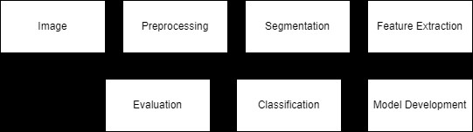

**RaidenNET Architecture**

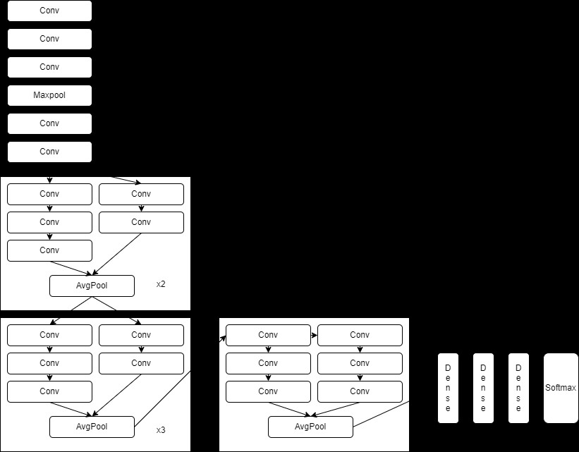

1. RESULTS

RaidenNet demonstrated outstanding performance in medical image analysis, achieving a remarkable accuracy of 86.59%. The preprocessing pipeline involving image scaling, segmentation, 3D-OCT processing effectively enhanced the visibility of medical features. Evaluation metrics, including precision, recall, and F1 score, further validated the model's reliability. Visual assessments through confusion matrices and sample predictions highlighted RaidenNET's superior ability to discern intricate details within medical images. Comparative analyses with baseline models and state-of-the-art architectures in the medical image analysis domain underscored RaidenNET's exceptional accuracy. The model exhibited robustness against variations in input data, emphasizing its potential for real-world applications. Collaborations with medical professionals affirmed the clinical relevance of RaidenNET, validating its capability to accurately identify and preserve critical medical features. In conclusion, RaidenNET's results position it as a highly effective tool for advancing medical image analysis, offering significant promise for enhancing diagnostic precision in clinical settings.

The below figures depicts the accuracy obtained:

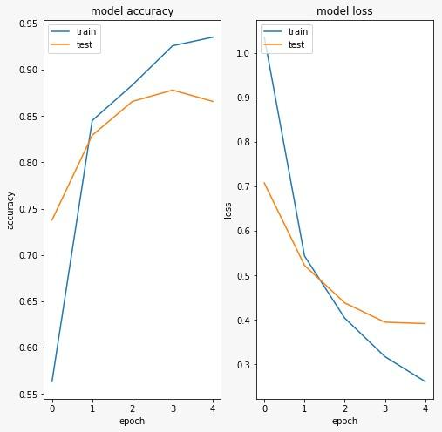

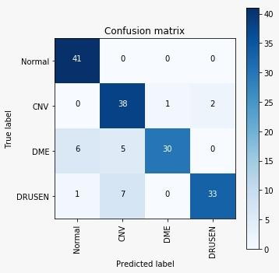

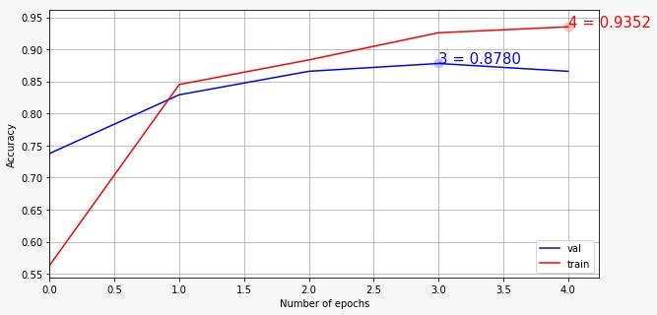

|  | ResNET | VGGNET | RaidenNET |
| --- | --- | --- | --- |
| Accuracy | 83.21 | 81.43 | 86.59 |

Table: *Accuracy comparison*

CONCLUSION

In conclusion, the integration of deep learning, particularly Convolutional Neural Networks (CNNs), in retinal damage detection through Optical Coherence Tomography (OCT) images has demonstrated significant progress. Leveraging techniques such as image scaling and segmentation during data preprocessing enhances the model's capacity to extract relevant features from 3D-OCT data. The iterative process of model development, including innovative approaches for feature extraction, results in refined diagnostic capabilities. Evaluation metrics, such as sensitivity and specificity, quantify the model's performance, while cross-validation techniques and testing on independent datasets ensure robustness. Addressing challenges in interpretability is crucial for seamless integration into clinical workflows. Collaborative efforts between researchers, clinicians, and technologists hold promise for transformative advancements in ocular healthcare, ultimately improving patient outcomes.The experimental validation of RaidenNET on benchmark datasets is recommended to assess its performance and generalization capabilities in comparison to existing state-of-the-art architectures.

References

[1] Donald C Hood, & Ali S Raza. (2014). On improving the use of OCT imaging for detecting glaucomatous damage. British Journal of

Ophthalmology, 98(Suppl 2), ii1. doi:10.1136/bjophthalmol-2014-305156

[2] Hood, D. C., Greenstein, V. C., Holopigian, K., Bauer, R., Firoz, B., Liebmann, J. M., … Ritch, R.(2000). An Attempt to Detect Glaucomatous Damage to the Inner Retina with the Multifocal ERG. Investigative Ophthalmology & Visual Science, 41(6), 1570–1579.

[3] Pascual-Prieto J, Burgos-Blasco B, Ávila Sánchez-Torija M, et al. Utility of optical coherence tomography angiography in detecting vascular retinal damage caused by arterial hypertension. European Journal of Ophthalmology. 2020;30(3):579-585. doi:10.1177/1120672119831159

[4] Leung, C. K.-S., & Weinreb, R. N. (2009). Experimental detection of retinal ganglion cell damage in vivo. Experimental Eye Research, 88(4), 831–836. doi:10.1016/j.exer.2008.09.006

[5] Sinha, B. B., Wary, A., Dhanalakshmi, R., & Balakrishnan, K. (2023). 5 - Transfer learning-based detection of retina damage from optical coherence

tomography images. In D. J. Hemanth (Ed.), Computational Methods and Deep Learning for Ophthalmology (pp. 71–88). doi:10.1016/B978-0-323-95415-0.00002-4

[6] Lavinsky, F., Wu, M., Schuman, J. S., Lucy, K. A., Liu, M., Song, Y., … Wollstein, G. (2018). Can Macula and Optic Nerve Head Parameters Detect Glaucoma Progression in Eyes with Advanced Circumpapillary Retinal Nerve Fiber Layer Damage? Ophthalmology, 125(12), 1907–1912. doi:10.1016/j.ophtha.2018.05.020

[7] Courant, D.; Court, L.; Abadie, B.; Brouillet, B. (1989) Retinal damage thresholds from single-pulse laser exposures ... : Health physics (no date a) LWW. Available at: https://journals.lww.com/health-physics/Abstract/1989/

05000/Retinal_Damage_Thresholds_from_Single_pulse_Laser.6.aspx

[8] Wong, T. Y., Klein, R., Klein, B. E. K., Tielsch, J. M., Hubbard, L., & Nieto, F. J. (2001). Retinal Microvascular Abnormalities and their Relationship with Hypertension, Cardiovascular Disease, and Mortality. Survey of Ophthalmology, 46(1), 59–80.doi:10.1016/S0039-6257(01)00234-X

[9] Nakayama, Y., Yokoi, T., Sachiko, N., Okuyama, M., & Azuma, N. (2013). Electroretinography combined with spectral domain optical coherence tomography to detect retinal damage in shaken baby syndrome. Journal of American Association for Pediatric Ophthalmology and Strabismus, 17(4),

411–413. doi:10.1016/j.jaapos.2013.02.011

[10] Leung, C. K.-S., Medeiros, F. A., Zangwill, L. M., Sample, P. A., Bowd, C., Ng, D., … Weinreb, R. N. (2007). American Chinese Glaucoma Imaging Study: A Comparison of the Optic Disc and Retinal Nerve Fiber Layer in Detecting Glaucomatous Damage. Investigative Ophthalmology & Visual Science, 48(6), 2644–2652. doi:10.1167/iovs.06-1332